32 Chinna ShodhaYatra
Yellendu to Gundala
Dist Bhadradri- Kothagudem, Telangana
20-22 September, 2019

Thirty Second Chinna Shodha Yatra (32 CSY)
Date: 20-22 September, 2019
Location: Yellendu to Gundala, Dist Bhadradr- Kothagudem, Telangana
Meeting Point: Yellendu
Starts: Yatra commences at 8 AM on Friday, 20 September, 2019 from Yellendu
Ends: At Gundala @ 5 PM on Sunday, 22 September, 2019.
Total Distance: Approximately 58 km.
Route map:
https://goo.gl/maps/kvtBFD1bDbRnjwTK7

To reach the Meeting Point:
Yellendu can be reached by road from Khammam and Mahabubabad. Khammam and Mahbubababd are on trunk railway line. Buses are available at high frequency from these stations. It is around 50 Kms from both towns with a traveling time of max 2 hours.

Return Journey:
On 22 September, 2019, Yatries will be able to reach Yellendu by 7 PM. Return journey from Khammam or Mahabubababd may be planned after 9 PM.

Route we walk…..
20 Sep – Yellendu , Rompedu, Sithanagaram, Mamidigudem, Komuraram, Pocharam,
21 Sep – Regulagudem, Shettipalli, Gorikala gudem, Chembunigudem, Galaba
22 Sep - Pothireddy gudem, Jagaigudem, Gundala

The Yatra area offers:
The region is very scenic with beautiful hills, green valleys and rivulets flowing with fresh water from hills. Maize is the major crop and the fields are lush green with the crops. People are friendly, hardworking and happier lot. Children laugh a lot and very social. The area is quiet with no traces of pollution or degradation of nature whatsoever. Nature dominates the area projecting its best and locals cherish the patronage of nature with gratitude. If you miss it, you miss something quite substantial which cannot be described easily.

The objectives and other details of the Yatra are described in the brochure placed on the home page of website http://www.pallesrujana.org/. Please read the Brochure carefully for finer details of Yatra. Tips given therein will help you plan the yatra logistics.

You may also read the impressions of yatris who participated in earlier Chinna Shodha Yatras on the website.

Administration
Registration fee of Rs 500 per participant is to be paid at the beginning of the yatra which will be used against the pre-yatra expenses of planning and reconnaissance by Volunteers of Palle Srujana.

Logistics and food expenses during the Yatra will be equally borne by the participants. Estimated expense is Rs 500-700 per Yatri depending on the number of participants. This amount will be collected at the commencement of Yatra by one of the Yatries voluntarily. He/she will maintain the accounts and present the same to the group just before the conclusion of the yatra.

Registration and Cancellation
Please visit www.pallesrujana.org and register online. You can also register by opening the link below.
https://forms.gle/YukxXCosA822kQ126
Last date of registration Noon 19 September, 2019.

A confirmation of your participation will be sent to you on online registration. In case you wish to cancel the participation after being confirmed, it is incumbent on you to intimate us asap.
Book your to and fro journey and share your travel details with Palle Srujana team and other yatries.

An exclusive whatsapp group for 32 CSY will be opened from 17 September, 2019 and all participants who received confirmation will be included in this group.

Important:

On 20 Sep at 8 AM, we will have a “Unlearning Session” which is very crucial to have a meaningful Yatra. Please do not miss it. Those who cannot help may miss yatra.

Private cars are not allowed along the yatra route.

Photos of Previous Yatra:
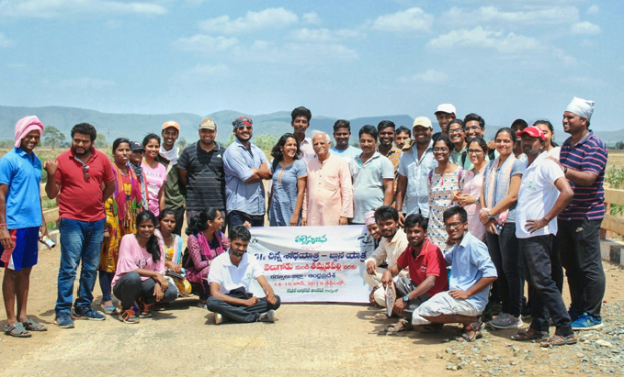

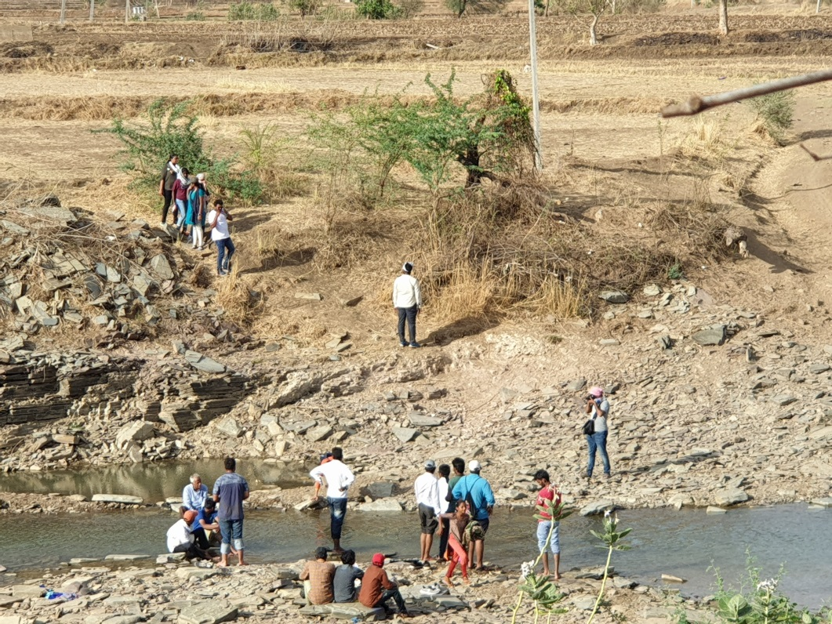
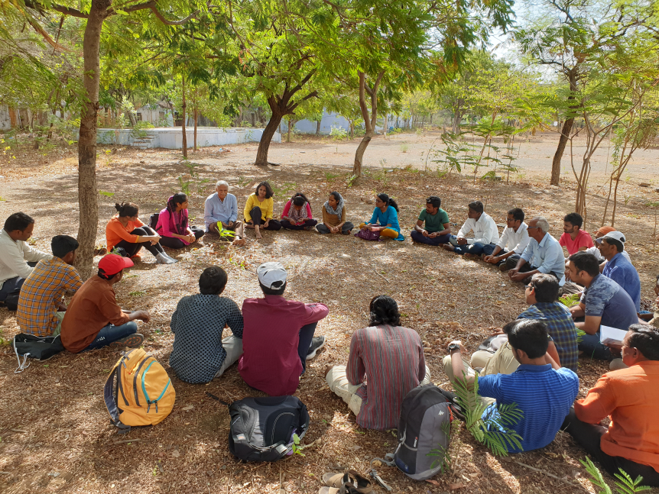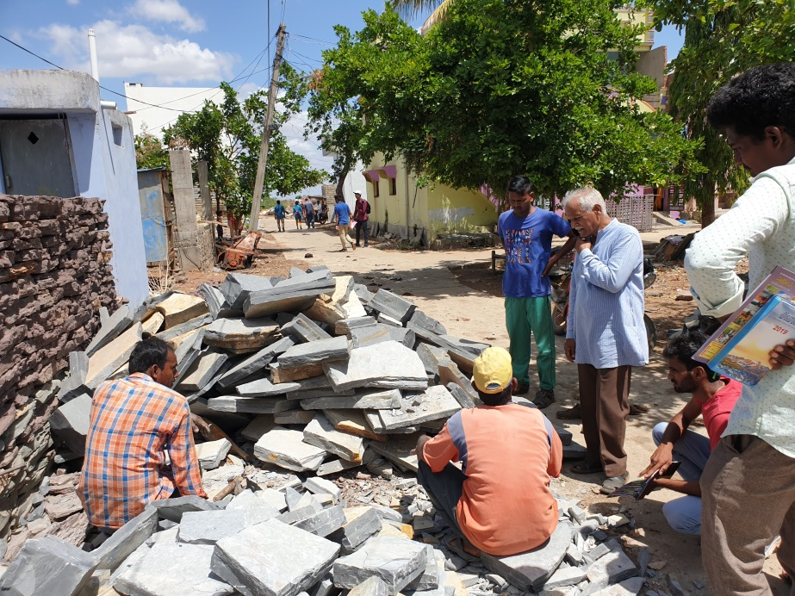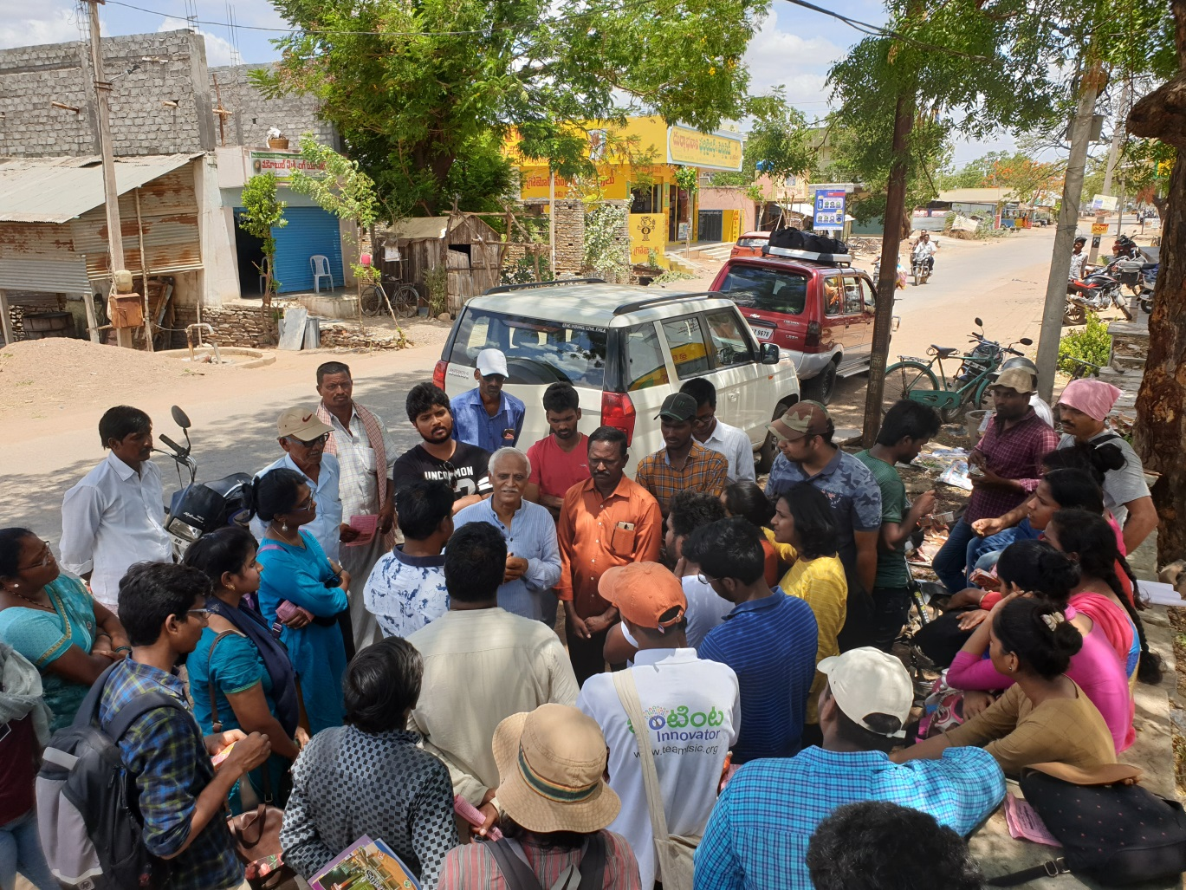
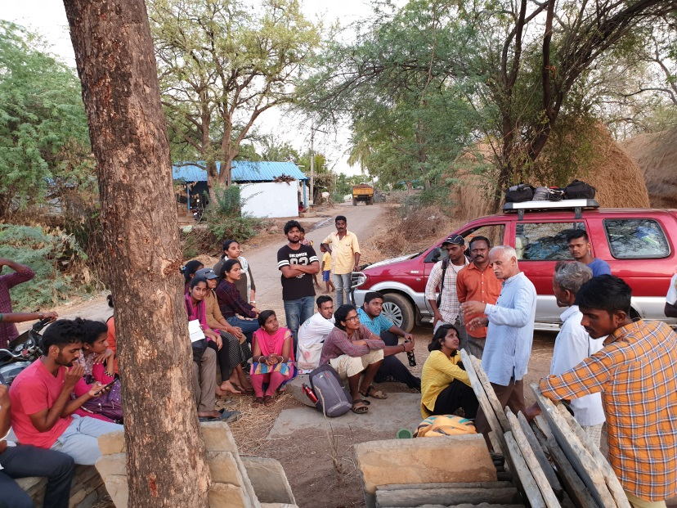
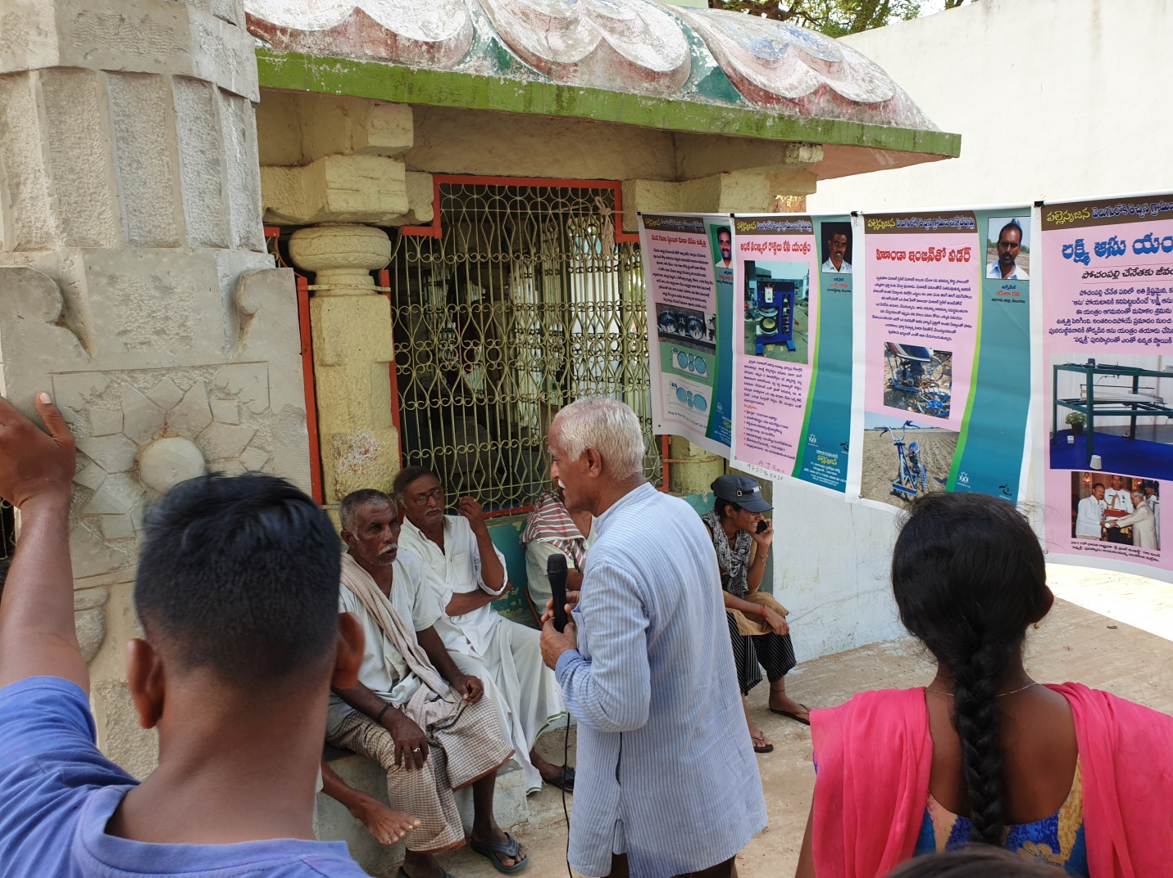
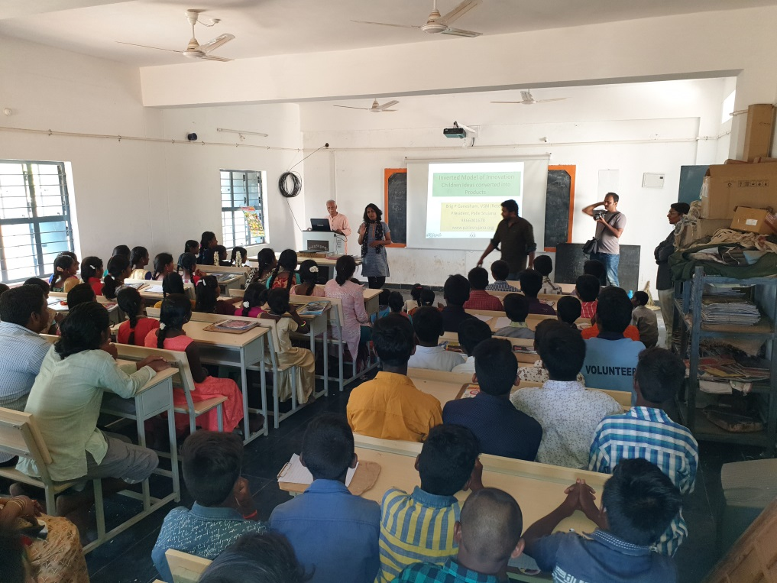

For any queries, please contact or email to:
Coordinators for the Yatra
Raju M, 95028 55858, raju.nif@gmail.com
Shiva - 7416663966, m.sivasitaram@gmail.com
Brig P Ganesham, 9866001678, president@pallesrujana.org

Please disseminate this flier among your network.

Team Palle Srujana
Secunderabad
September, 2019

